Abstract class
- There is a situation in which you want to define a super class that declares the structure of a given abstraction without providing a complete implementation of every method.
- That is sometimes you want to create a super class or parent class that only defines a generalized method and that method you want to share by all of its sub-classes or child classes, leaving it to be each sub class to implement method.
- Abstract class determines the nature of the methods that the sub-classes must implement.
- Abstract class means a class which is declared with the “abstract” keyword and abstract class may or may not include abstract method.
- Abstract methods means a method which are only declared but not defined (means abstract method does not have body).
- Abstract class needs to be extended and its method implemented. Means the abstract methods which are there in super class must be override in sub-class otherwise it will give you error message.
- We can’t create an instance of an abstract class because it is an incomplete class.
Points to Remember
- An abstract class must be declared with an abstract keyword.
- It can have abstract and non-abstract methods.
- It cannot be instantiated.
- It can have constructors and static methods also.
- It can have final methods which will force the subclass not to change the body of the method.
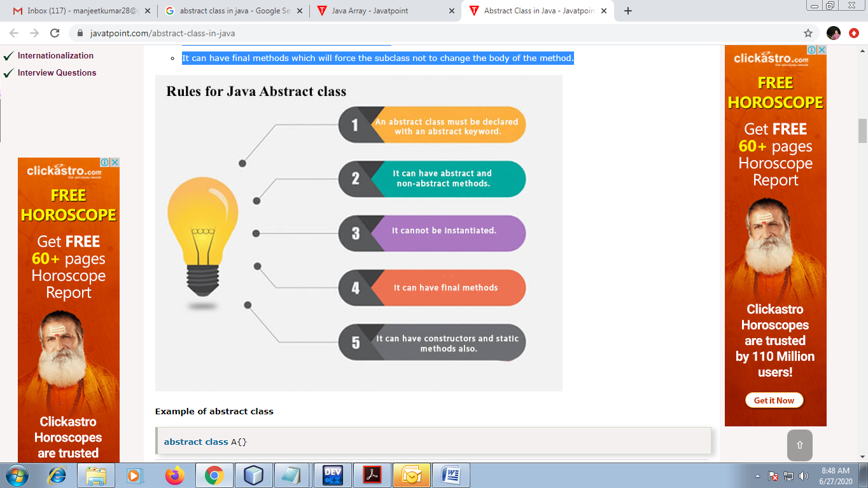
Eg:
abstract Shape
public abstract void draw();

Triangle

Square

Rectangle

In this example, Shape is the abstract class, and its implementation is provided by the Triangle Rectangle and Square classes.
Syntax to create abstract class:

<abstract> <class> <calss_name)
{
//body
}

Syntax to create abstract method:

<access-modifier> <abstract> <retruen-type> <method_name>()
{

}

abstract class Shape{
abstract void draw();
}
//In real scenario, implementation is provided by others i.e. unknown by end user
class Triangle extends Shape{
void draw(){System.out.println("drawing triangle");}
}

class Rectangle extends Shape{
void draw(){System.out.println("drawing rectangle");}
}
class Square extends Shape{
void draw(){System.out.println("drawing square");}
}
//In real scenario, method is called by programmer or user
class TestAbstraction1{
public static void main(String args[]){
Triangle t=new Triangle();
t.draw();
Rectangle r=new Rectangle();
r.draw();
}
}

Eg:
abstract class Bank{
abstract int getRateOfInterest();
}
class SBI extends Bank{
int getRateOfInterest(){return 7;}
}
class PNB extends Bank{
int getRateOfInterest(){return 8;}
}

class TestBank{
public static void main(String args[]){
Bank b;
b=new SBI();
System.out.println("Rate of Interest is: "+b.getRateOfInterest()+" %");
b=new PNB();
System.out.println("Rate of Interest is: "+b.getRateOfInterest()+" %");
}}

Abstract class having constructor, data member and methods
An abstract class can have a data member, abstract method, method body (non-abstract method), constructor.

//Example of an abstract class that has abstract and non-abstract methods
abstract class Bike{
Bike(){System.out.println("bike is created");}
abstract void run();
void changeGear(){System.out.println("gear changed");}
}
//Creating a Child class which inherits Abstract class
class Honda extends Bike{
void run(){System.out.println("running safely..");}
}
//Creating a Test class which calls abstract and non-abstract methods
class Test{
public static void main(String args[]){
Bike obj = new Honda();
obj.run();
obj.changeGear();
}
}
Output:
bike is created
running safely..
gear changed

Question: Define an abstract class Staff with members’ names and addresses and abstract method i.e. accept and display. Define two sub-classes of this class – “FullTimeStaff” (department, salary) and “PartTimeStaff” (number-of-hours, rate-per hour). Appropriate method. Create n objects which could be of either FullTimeStaff or PartTimeStaff class by asking the user’s choice. Display details of all “FullTimeStaff” objects and all “PartTimeStaff” objects.
import java.io.BufferedReader;
import java.io.IOException;
import java.io.InputStreamReader;
abstract class Staff{
String name,address;
public abstract void accept();
public abstract void display();
}
class FullTimeStaff extends Staff{
String department;
double salary;
public void accept() throws IOException{
System.out.println("Enter the name, address, department and salary: ");
BufferedReader br=new BufferedReader(new InputStreamReader(System.in));
name=br.readLine();
address=br.readLine();
department=br.readLine();
salary=Double.parseDouble(br.readLine());
}
public void display(){
System.out.println("Name: "+name);
System.out.println("Address: "+address);
System.out.println("Department: "+department);
System.out.println("Salary: "+salary);
System.out.println("----------------------");
}
}

class PartTimeStaff extends Staff{
int hours, rate;
public void accept() throws IOException{
System.out.println("Enter the name, address, No of working hours and rate per hour: ");
BufferedReader br=new BufferedReader(new InputStreamReader(System.in));
name=br.readLine();
address=br.readLine();
hours=Integer.parseInt(br.readLine());
rate=Integer.parseInt(br.readLine());
}
public void display(){
System.out.println("Name: "+name);
System.out.println("Address: "+address);
System.out.println("No of Working Hours: "+hours);
System.out.println("Rate per hour: "+rate);
System.out.println("----------------------");
}
}

public class Menu {
public static void main(String [] args) throws IOException{
int i;
System.out.println("Select Any One: ");
BufferedReader br=new BufferedReader(new InputStreamReader(System.in));
System.out.println("1.Full Time Staff");
System.out.println("2.Part Time Satff");
int ch=Integer.parseInt(br.readLine());
switch(ch){
case 1:
System.out.println("Enter the number of Full Time Staff: ");
int n=Integer.parseInt(br.readLine());

FullTimeStaff [] l=new FullTimeStaff[n];
for(i=0;i<n;i++){
l[i]=new FullTimeStaff();
l[i].accept();
}
for(i=0;i<n;i++){
l[i].display();
}
break;
case 2:
System.out.println("Enter the number of Part Time Staff: ");
int m=Integer.parseInt(br.readLine());
PartTimeStaff [] h=new PartTimeStaff[m];
for(i=0;i<m;i++){
h[i]=new PartTimeStaff();
h[i].accept();
}
for(i=0;i<m;i++){
h[i].display();
}
break;

}
}
}

Q: created an abstract class CalculatorOperation with the following abstract method i.e add(), subs(), multi() and div().
Create a menu driven program in Calculator class such as 1 for Addition, 2 for Subtract, 3 for Multiplication, 4 for Division and 5 for Exit. In order to implement the class Calculator use abstract CalculatorOperation class.

Q. Write a JAVA program which has
i. An Abstract class for Stack Operations
ii. A Class that implements the abstract Stack class and creates a fixed length Stack.

